1.INTRODUCTION
Tourism is one of the important activities in modern society. People travel for different purposes such as holidays, education, business, cultural experiences, adventure, relaxation, and religious visits. Before travelling to a new place, a person generally needs information about the destination, tourist attractions, hotels, food, shopping places, transportation, travel plans, and other facilities. Collecting all this information from different sources can be time-consuming and sometimes confusing.
With the development of information technology and the internet, tourism-related information is increasingly being accessed through websites and online applications. However, users may still need to use multiple platforms to search for different types of travel information. One website may provide information about destinations, another may provide hotel information, while another may provide maps, reviews, or travel planning facilities. Because of this, the complete travel planning process can become lengthy and difficult, especially for users who want a simple and organized platform.
The Smart Tourism and Travel Assistant is developed to provide a centralized web-based platform for exploring tourist destinations and assisting users in planning their trips. The main idea of this project is to bring commonly required tourism information and travel-planning facilities together in one application. The system provides a simple and attractive interface through which users can explore destinations, view tourist attractions, search for hotels, plan trips, and proceed towards hotel booking.
The project is designed as a responsive tourism website, meaning that the interface can adjust to different screen sizes and devices. Users can access the website using a desktop, laptop, tablet, or mobile device. The system uses a clear navigation structure so that users can easily move between different sections of the application.
The Home page acts as the main entry point of the system. It provides navigation to the major modules of the application, such as Destinations, Trip Planner, Hotels, About, Help, Login, and Register. A destination search facility is also provided so that users can quickly search for a particular tourist destination.
The Destinations module is one of the main components of the system. It provides users with a collection of tourist destinations. Users can search for destinations and filter the available destinations according to the provided categories. This makes it easier for users to find a destination without manually going through every available option.
The system also provides destination detail pages. These pages provide more information about a selected destination. For example, a destination such as Jaipur can contain information about major tourist attractions including Amber Fort, Hawa Mahal, City Palace, Jantar Mantar, Jal Mahal, Nahargarh Fort, Jaigarh Fort, and Albert Hall Museum. Along with tourist attractions, destination pages can provide information about famous food, shopping, culture, and useful travel tips. This allows users to understand the destination before planning their visit.
Another important component of the system is the Hotel module. When users plan a trip, accommodation is one of the important requirements. The Hotel module allows users to explore available hotel options. Users can search and filter hotels according to the available location or category. Hotel information is presented in a simple card-based layout so that users can easily compare available options.
The system also includes a Hotel Booking module. When a user selects the Book Now option for a particular hotel, the system transfers the selected hotel information to the booking page. The user can then enter booking-related information such as full name, email address, mobile number, number of guests, check-in date, check-out date, room type, and special requests. This creates a proper flow from hotel selection to booking.
The Trip Planner module is included to assist users in organizing their travel requirements. Instead of searching for different travel details separately, users can enter their trip-related information through the planner interface. This module provides the foundation for developing a more advanced travel-planning system in the future.
The application also contains Login and Register modules. These modules provide the basic structure required for user account management. In the current frontend implementation, these pages provide the user interface, while actual authentication and database-based user management can be implemented through the planned backend.
The Help module provides users with assistance regarding the application. It is included to make the system easier to understand and use. The About module provides information about the purpose and concept of the Smart Tourism and Travel Assistant.
The frontend of the project is developed using HTML, CSS, Bootstrap, and JavaScript. HTML is used to create the structure of the web pages, CSS is used for styling and visual presentation, Bootstrap is used to create responsive layouts and components, and JavaScript is used to implement interactive features such as searching, filtering, navigation, and hotel booking redirection.
The project is planned to be extended with a backend using Java and Spring Boot. The backend will provide the server-side functionality required for handling users, destinations, hotels, bookings, and trip information. PostgreSQL is planned as the database for storing and managing application data. With backend and database integration, the system can be converted from a frontend-based tourism website into a complete dynamic tourism management application.
The project follows a modular approach in which different tourism-related functionalities are organized into separate pages and modules. This makes the application easier to understand, maintain, test, and extend. New features can also be added in the future without completely changing the existing structure of the application.
The main objective of the Smart Tourism and Travel Assistant is therefore to simplify the travel planning process by providing tourism information and travel-related facilities through a single, organized, and user-friendly web application. The project combines destination exploration, destination information, hotel searching, booking, and trip planning into one platform.
In the future, the system can be enhanced with advanced features such as real-time weather information, maps and navigation, transportation information, user reviews and ratings, personalized recommendations, online payment, real-time hotel availability, AI-based travel assistance, and complete database-driven booking management.
Overall, the Smart Tourism and Travel Assistant provides a foundation for developing a modern tourism platform that can reduce the effort required for travel planning and make tourism information easier to access and manage.

1.1 ABSTRACT
The Smart Tourism and Travel Assistant is a web-based tourism application developed to make the process of exploring destinations and planning trips easier, faster, and more organized. The main purpose of this project is to provide users with tourism-related information and useful travel facilities through a single platform instead of requiring them to search different sources separately.
The system allows users to explore various tourist destinations and obtain detailed information about important attractions, famous food, shopping places, culture, and travel tips. Users can search and filter destinations according to their requirements. The application also provides a Hotel module, where users can explore hotel options, search for hotels, and select a suitable hotel for booking.
The Hotel Booking module provides a structured booking form through which users can enter details such as name, email, mobile number, number of guests, check-in date, check-out date, room type, and special requests. The system transfers the selected hotel information from the hotel page to the booking page, providing a simple flow for the user.
The application also includes a Trip Planner to help users organize their travel requirements. Additional modules such as Login, Register, About, and Help are provided to improve the overall usability and structure of the application.
The frontend of the system is developed using HTML, CSS, Bootstrap, and JavaScript. Bootstrap is used to create a responsive and attractive user interface, while JavaScript is used to implement interactive features such as destination searching, filtering, navigation, and hotel booking redirection. The application is designed to work on different devices including desktops, laptops, tablets, and mobile devices.
The project is planned for further development using Java with Spring Boot as the backend and PostgreSQL as the database. Backend integration will allow the system to store and manage user accounts, destination information, hotel details, trip plans, and booking records dynamically.
The Smart Tourism and Travel Assistant provides a foundation for a complete tourism management platform. In the future, the system can be enhanced with features such as real-time hotel availability, online payment, weather information, maps and navigation, user reviews and ratings, personalized destination recommendations, transportation information, and AI-based travel assistance. Thus, the proposed system aims to provide a simple, centralized, responsive, and user-friendly platform for tourism exploration and travel planning.

1.2Existing System Need of System
The existing system is mainly based on manual processes and traditional methods of managing In the existing tourism and travel planning process, users generally depend on different websites, mobile applications, search engines, and other online sources to collect travel-related information. Information about tourist destinations, attractions, hotels, food, shopping, transportation, and trip planning is often available on separate platforms.
For example, a user may search one website for information about a tourist destination, another website for hotels, and another source for travel tips or attractions. The user then has to compare and organize this information manually before making a travel plan. This process can be time-consuming and inconvenient.
Need of System
The need for this system is mainly based on reducing the effort and time required for travel planning. Instead of collecting information from many different sources, users can access important tourism-related features through a single application.
The proposed system also provides a foundation for future development. By integrating the planned Java Spring Boot backend and PostgreSQL database, the application can later store user information, destination details, hotel information, trip plans, and booking records. This will make the system more dynamic and useful for real-world tourism management.
Therefore, the Smart Tourism and Travel Assistant is needed to provide a simple, centralized, organized, responsive, and user-friendly platform for exploring destinations and planning trips.

1.3 SCOPE OF PROJECT
The Smart Tourism and Travel Assistant is designed to provide a centralized platform for exploring tourist destinations and assisting users in planning their trips. The scope of the project covers different activities related to destination exploration, travel planning, hotel searching, and hotel booking.
The major scope of the project is described below:

1. Destination Exploration
The system allows users to explore different tourist destinations through a single website. Users can view a list of destinations and select a destination according to their interests.

2. Destination Search and Filtering
The application provides search and filtering functionality to help users find destinations easily. Instead of manually checking every destination, users can search for a particular destination and use the available categories to narrow down the results.

3. Detailed Destination Information
The system provides separate destination-detail pages containing useful information about selected destinations. The information can include:
- Major tourist attractions
- Famous food
- Shopping places
- Local culture
- Travel tips
- Basic information about the destination
This helps users understand a destination before planning their visit.

4. Tourist Attraction Information
The project covers information about important tourist attractions within selected destinations. For example, the Jaipur section includes attractions such as Amber Fort, Hawa Mahal, City Palace, Jantar Mantar, Jal Mahal, Nahargarh Fort, Jaigarh Fort, and Albert Hall Museum.

5. Hotel Search and Exploration
The system provides a dedicated Hotels section where users can explore hotel options related to different destinations. Users can search and filter hotels to find a suitable accommodation option.

6. Hotel Booking
The project includes a hotel booking flow. When a user selects Book Now, the selected hotel is passed to the booking page. The user can then enter:
- Full Name
- Email
- Mobile Number
- Number of Guests
- Check-in Date
- Check-out Date
- Room Type
- Special Request
This provides a structured interface for collecting booking information.

7. Trip Planning
The Trip Planner module helps users organize their travel requirements. It provides a foundation for creating a more detailed itinerary and personalized travel plan in future versions.

8. User Registration and Login
The project includes Register and Login pages. These provide the basic user interface required for user account functionality. In the future, these pages can be connected to the Java backend and PostgreSQL database for actual authentication and account management.

9. Help and Information
The Help section provides users with assistance regarding the application. The About section provides information about the purpose and concept of the Smart Tourism and Travel Assistant.

10. Responsive Web Application
The system is designed as a responsive web application. It can be accessed using different devices such as:
- Desktop computers
- Laptops
- Tablets
- Mobile phones
The use of Bootstrap helps maintain a consistent and responsive user interface.

11. Backend and Database Integration
The current project provides the frontend structure, while the planned backend will use Java with Spring Boot and PostgreSQL. The backend can be used to manage and store:
- User information
- Destination information
- Hotel information
- Trip plans
- Booking details

12. Future Expansion
The scope of the project can be extended by adding advanced tourism services such as:
- Real-time hotel availability
- Online payment
- Weather information
- Maps and navigation
- Transportation information
- User reviews and ratings
- Personalized destination recommendations
- AI-based travel assistance
- Complete online booking management

1.5 OPERATING SYSTEM-HARDWARE AND SOFTWARE
Hardware Minimum Requirement
Processor Intel Core i3 or equivalent
RAM 4 GB or above
Hard Disk / Storage 128 GB or above
Smartphone Android Smartphone
GPS GPS / Location Services Enabled
Internet Wi-Fi or Mobile Data Connection
Display Standard Monitor / Display
Keyboard Standard Keyboard
Mouse Standard Mouse
Battery Minimum 3000 mAh Smartphone Battery
USB Port USB 2.0 or above
Camera Smartphone Camera (Optional)
Microphone Smartphone Microphone
RAM | 4 GB or above
Storage | 128 GB or above
Smartphone | Android Smartphone
GPS | GPS / Location Services
Internet Wi-Fi / Mobile Data
Display | Standard Monitor
Keyboard | Standard Keyboard
Mouse | Standard Mouse

2. PROPOSE SYSTEM

2.1 STUDY OF SIMILAR SYSTEM
Several existing tourism and travel applications provide facilities such as destination search, hotel information, trip planning, and online booking. These systems were studied to understand their common features and limitations.
The Smart Tourism and Travel Assistant takes inspiration from these systems but focuses on providing a simple, attractive, and user-friendly interface with important tourism features in one platform.

Similar Systems
- Online Travel Websites – Provide destination information, hotel search, and booking facilities.
- Hotel Booking Applications – Mainly focus on searching hotels, comparing options, and making reservations.
- Tourism Information Websites – Provide information about tourist places, attractions, food, culture, and travel tips.

2.2 USERS OF SYSTEM:
• Tourists / Travellers – Can explore destinations, view tourist attractions, search hotels, and plan trips.
• Trip Planners – Can use destination and hotel information to prepare suitable travel plans.
• Students and Young Travellers – Can use the system to explore destinations and obtain basic travel information.
• Families and Groups – Can search for suitable destinations and hotels and manage basic booking information.
• Future Administrators – In the future, an admin module can be added to manage users, destinations, hotels, bookings, and other tourism information.

3. ANALYSIS AND DESIGN

3.1 System Requirements
- Functional Requirements:
• | • User Registration – The system should allow new users to register by providing the required details.
• | • User Login – Registered users should be able to log in to the system.
• | • Destination Search – Users should be able to search for tourist destinations.
• | • Destination Filtering – Users should be able to filter destinations according to available categories.
• | • Destination Details – The system should display detailed information about selected destinations, including tourist attractions, food, shopping, culture, and travel tips.
• | • Hotel Search – Users should be able to search and explore available hotels.
• | • Hotel Filtering – Users should be able to filter hotels according to location or available options.
• | • Hotel Booking – Users should be able to select a hotel and enter booking details such as name, contact information, number of guests, dates, and room type.
• | • Trip Planning – The system should provide a Trip Planner to help users organize their travel requirements.

- Non-Functional Requirements:
• | • Usability – The system should have a simple and user-friendly interface that is easy to understand.
• | • Performance – Web pages and user actions should respond quickly without unnecessary delay.
• | • Reliability – The system should work consistently and provide correct results for user operations.
• | • Security – User information and booking details should be protected from unauthorized access.
• | • Availability – The system should be accessible whenever users need to explore destinations or plan their trips.
• | • Maintainability – The system should be easy to modify, update, and maintain

3.2 Er Diagram

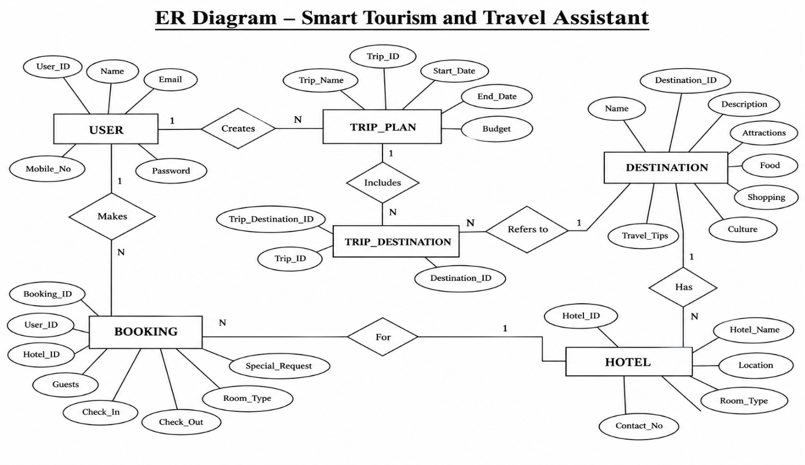

3.3 Table structure

Sr. No. | Table Name | Field Name | Data Type | Key | Description
1 | User | User_ID | INT | Primary Key | Unique identification number of the user
 |  | Name | VARCHAR | — | Name of the user
 |  | Email | VARCHAR | — | Email address of the user
 |  | Mobile_No | VARCHAR | — | Mobile number of the user
 |  | Password | VARCHAR | — | Login password of the user
2 | Destination | Destination_ID | INT | Primary Key | Unique identification number of destination
 |  | Name | VARCHAR | — | Name of the tourist destination
 |  | Description | TEXT | — | Detailed information about the destination
 |  | Attractions | TEXT | — | Major tourist attractions
 |  | Food | TEXT | — | Famous food of the destination
 |  | Shopping | TEXT | — | Popular shopping places
 |  | Culture | TEXT | — | Cultural information
 |  | Travel_Tips | TEXT | — | Useful travel information
3 | Hotel | Hotel_ID | INT | Primary Key | Unique identification number of hotel
 |  | Destination_ID | INT | Foreign Key | Identifies the destination associated with hotel
 |  | Hotel_Name | VARCHAR | — | Name of the hotel
 |  | Location | VARCHAR | — | Hotel location
 |  | Room_Type | VARCHAR | — | Type of room available
 |  | Contact_No | VARCHAR | — | Hotel contact number
4 | Booking | Booking_ID | INT | Primary Key | Unique identification number of booking
 |  | User_ID | INT | Foreign Key | Identifies the user making the booking
 |  | Hotel_ID | INT | Foreign Key | Identifies the selected hotel
 |  | Guests | INT | — | Number of guests
 |  | Check_In | DATE | — | Check-in date
 |  | Check_Out | DATE | — | Check-out date
 |  | Room_Type | VARCHAR | — | Selected room type
 |  | Special_Request | TEXT | — | Additional request from user
5 | Trip_Plan | Trip_ID | INT | Primary Key | Unique identification number of trip plan
 |  | User_ID | INT | Foreign Key | Identifies the user creating the trip
 |  | Trip_Name | VARCHAR | — | Name of the trip
 |  | Start_Date | DATE | — | Starting date of trip
 |  | End_Date | DATE | — | Ending date of trip
 |  | Budget | DECIMAL | — | Estimated trip budget
6 | Trip_Destination | Trip_Destination_ID | INT | Primary Key | Unique identification number
 |  | Trip_ID | INT | Foreign Key | Identifies the trip plan
 |  | Destination_ID | INT | Foreign Key | Identifies the destination included in trip

3.4 Use Case Diagram

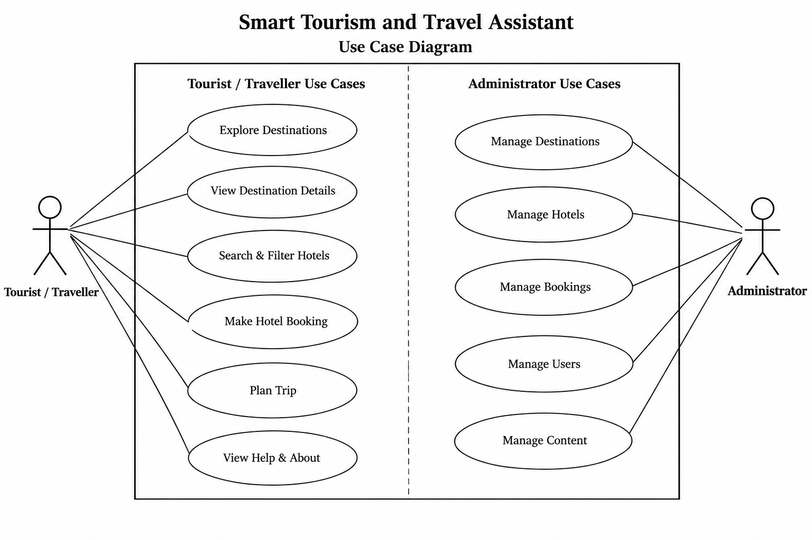

3.5 Class digram:

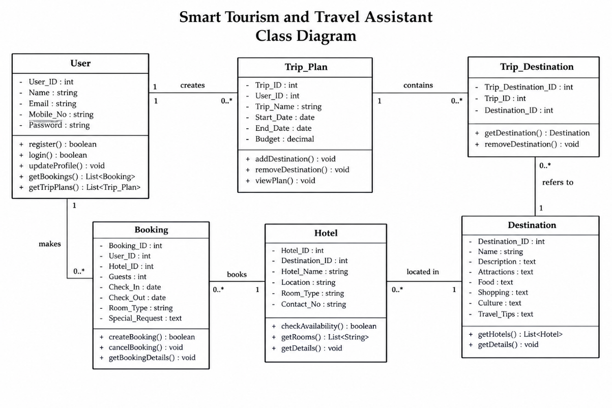

3.6 Activity Diagram
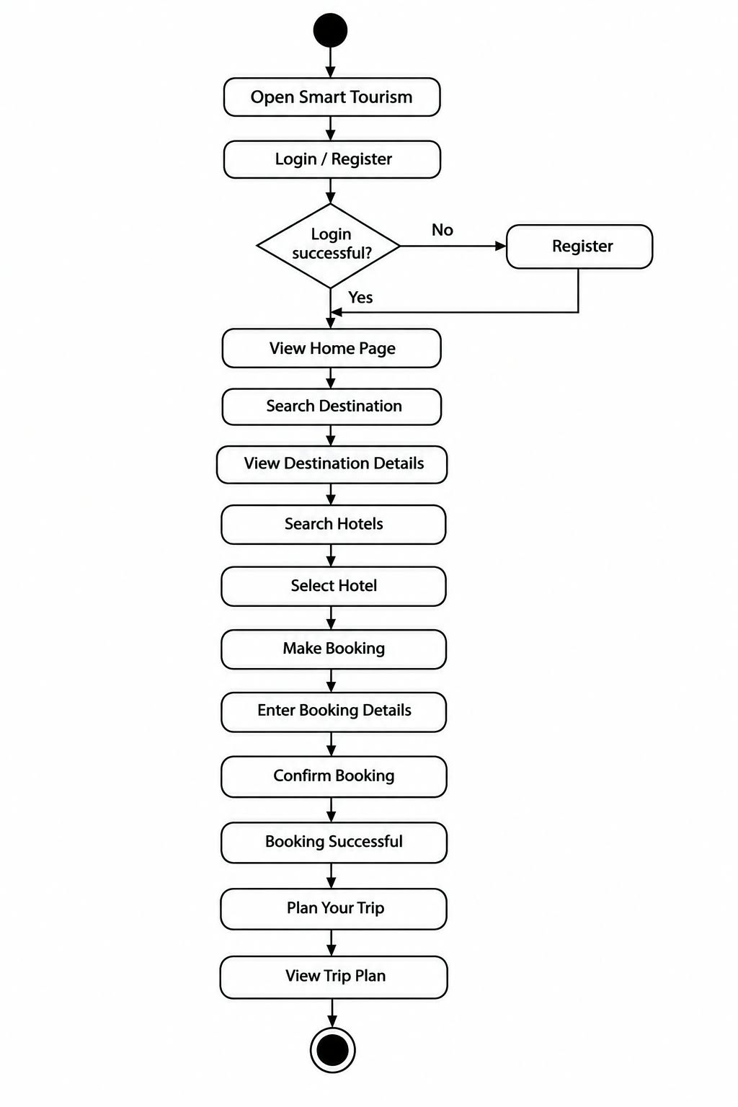

3.7 Data Flow Diagram

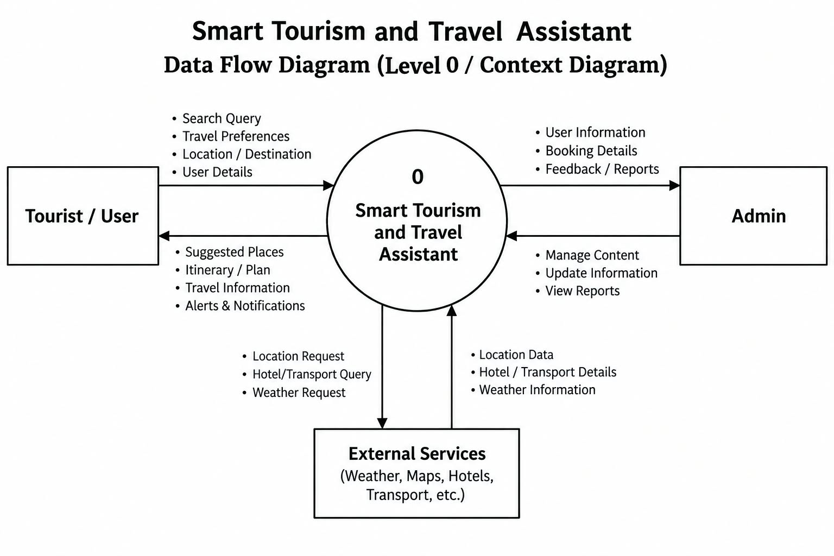

s1.Home Page:

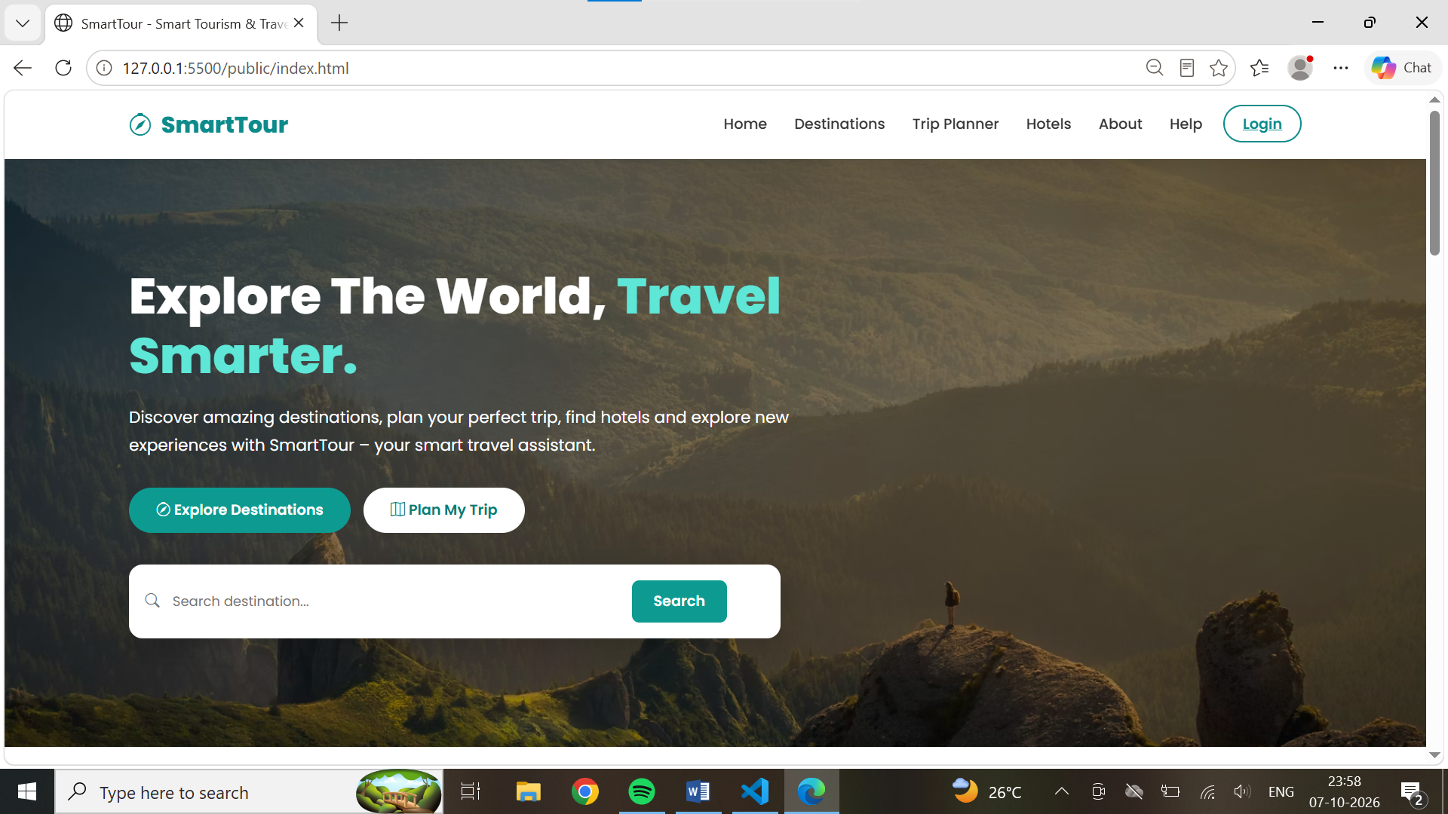

2.Login Page

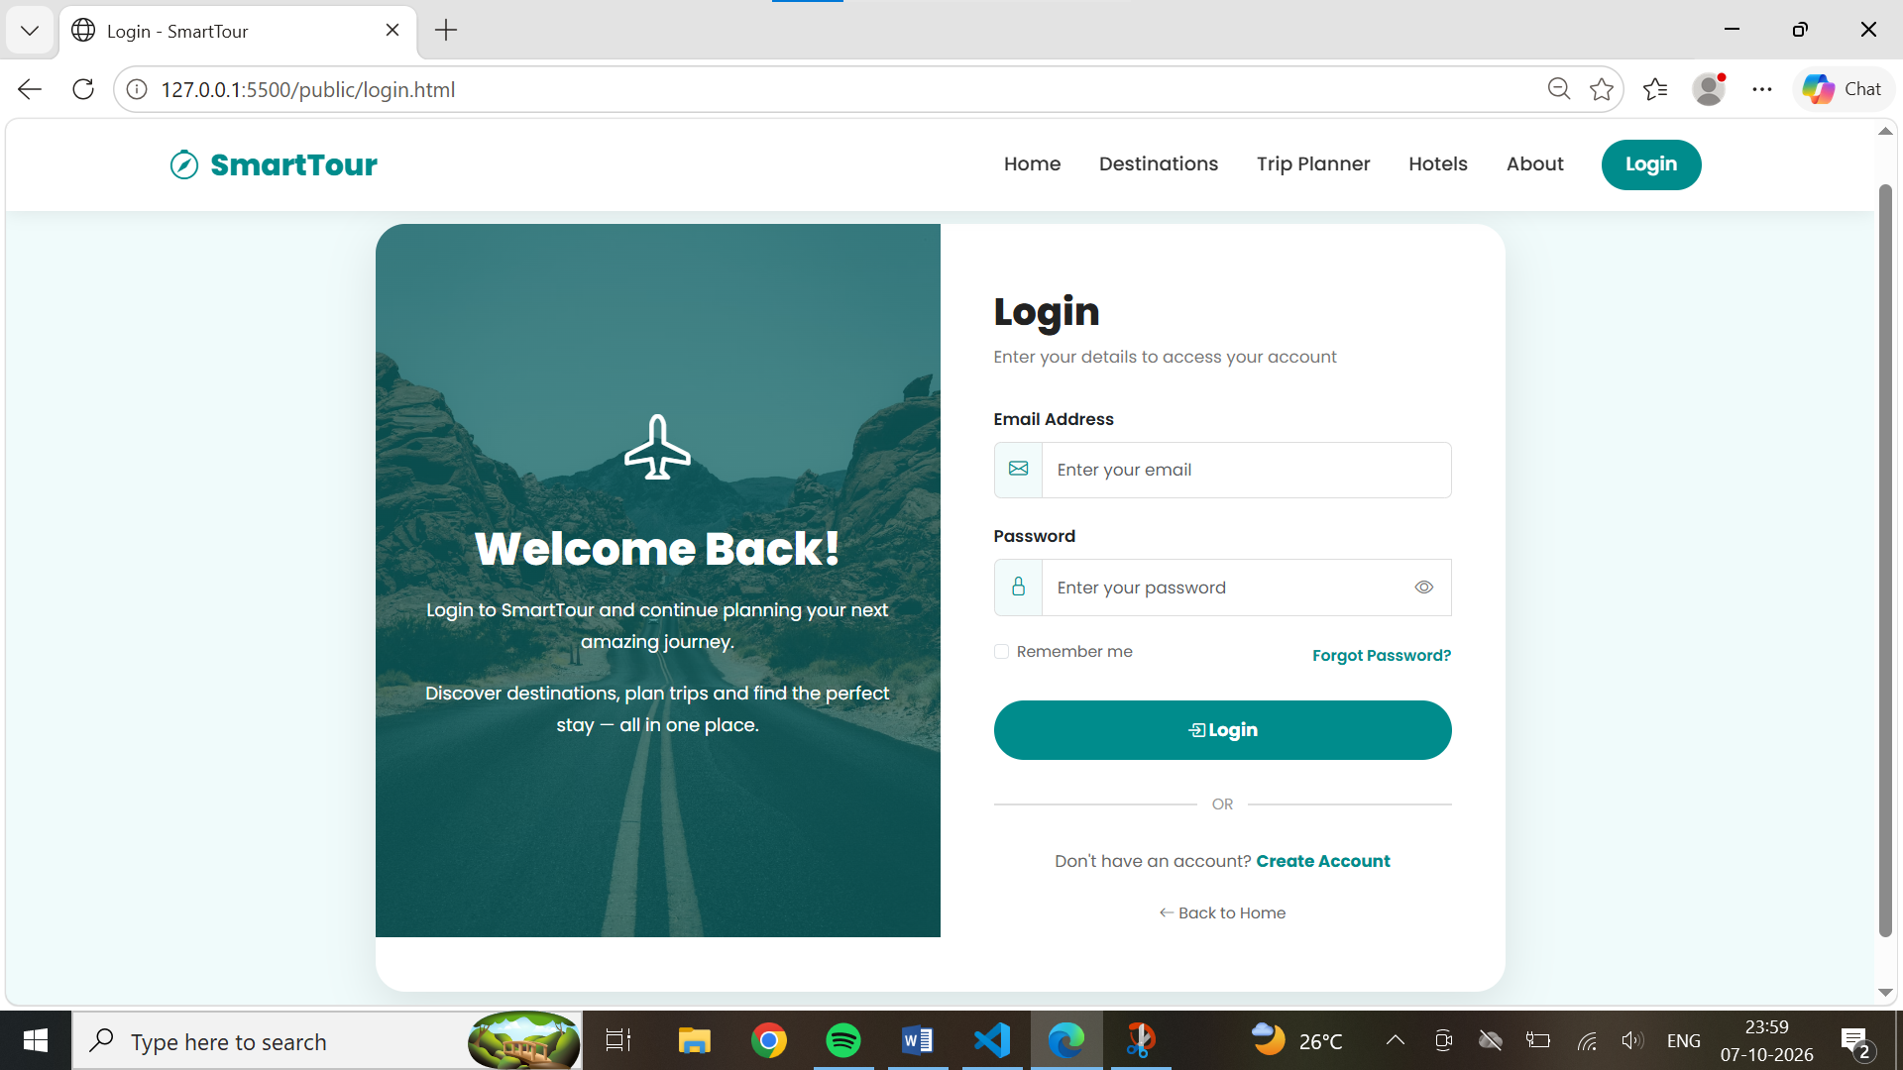

3.Registration Page:

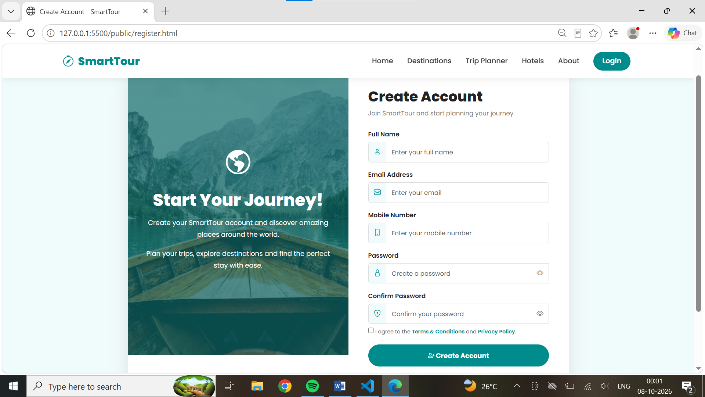

4.Hotels page

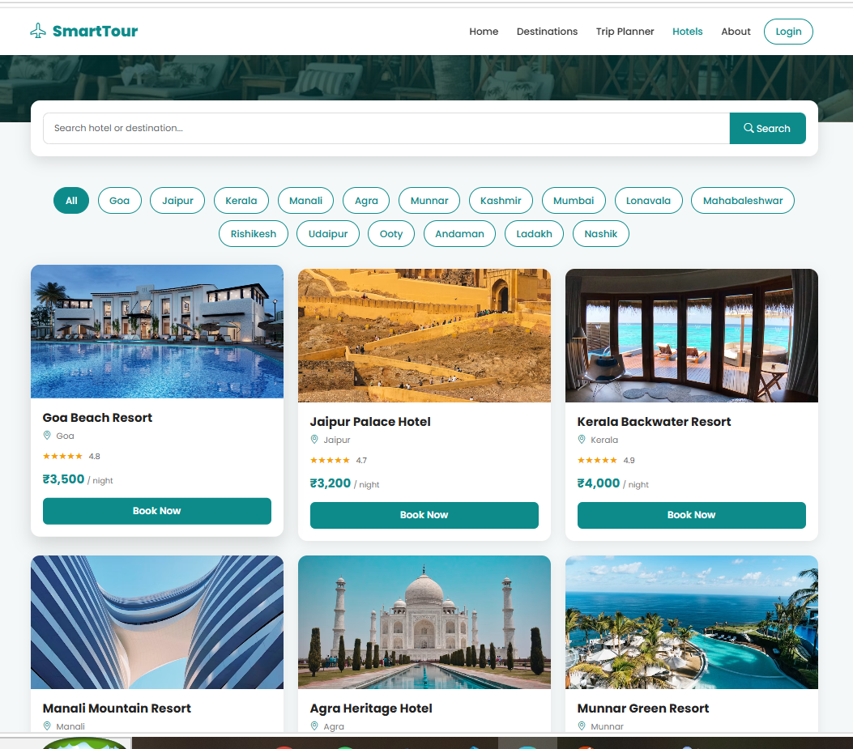

5.Destination Page:

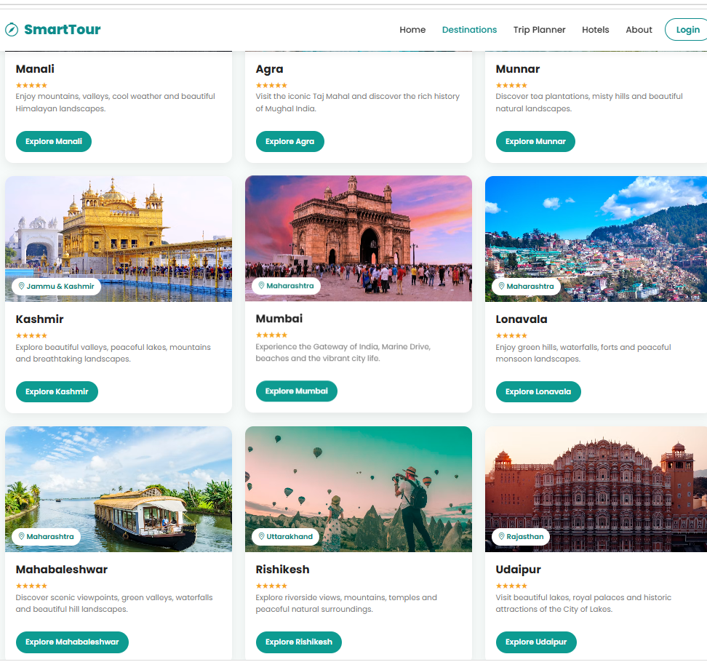

6.Trip Planner Page:

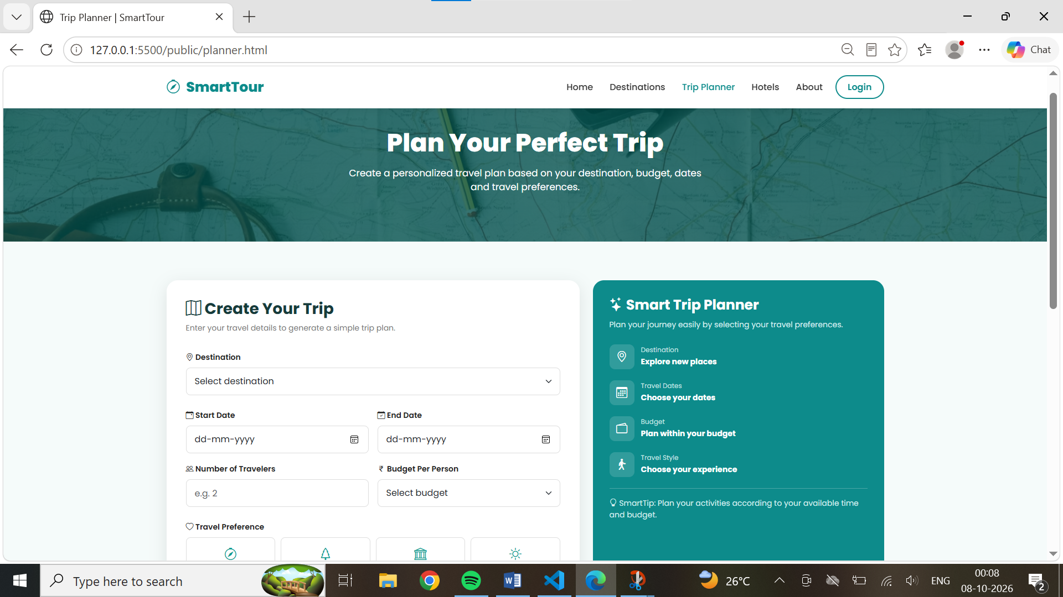

7.About us page:

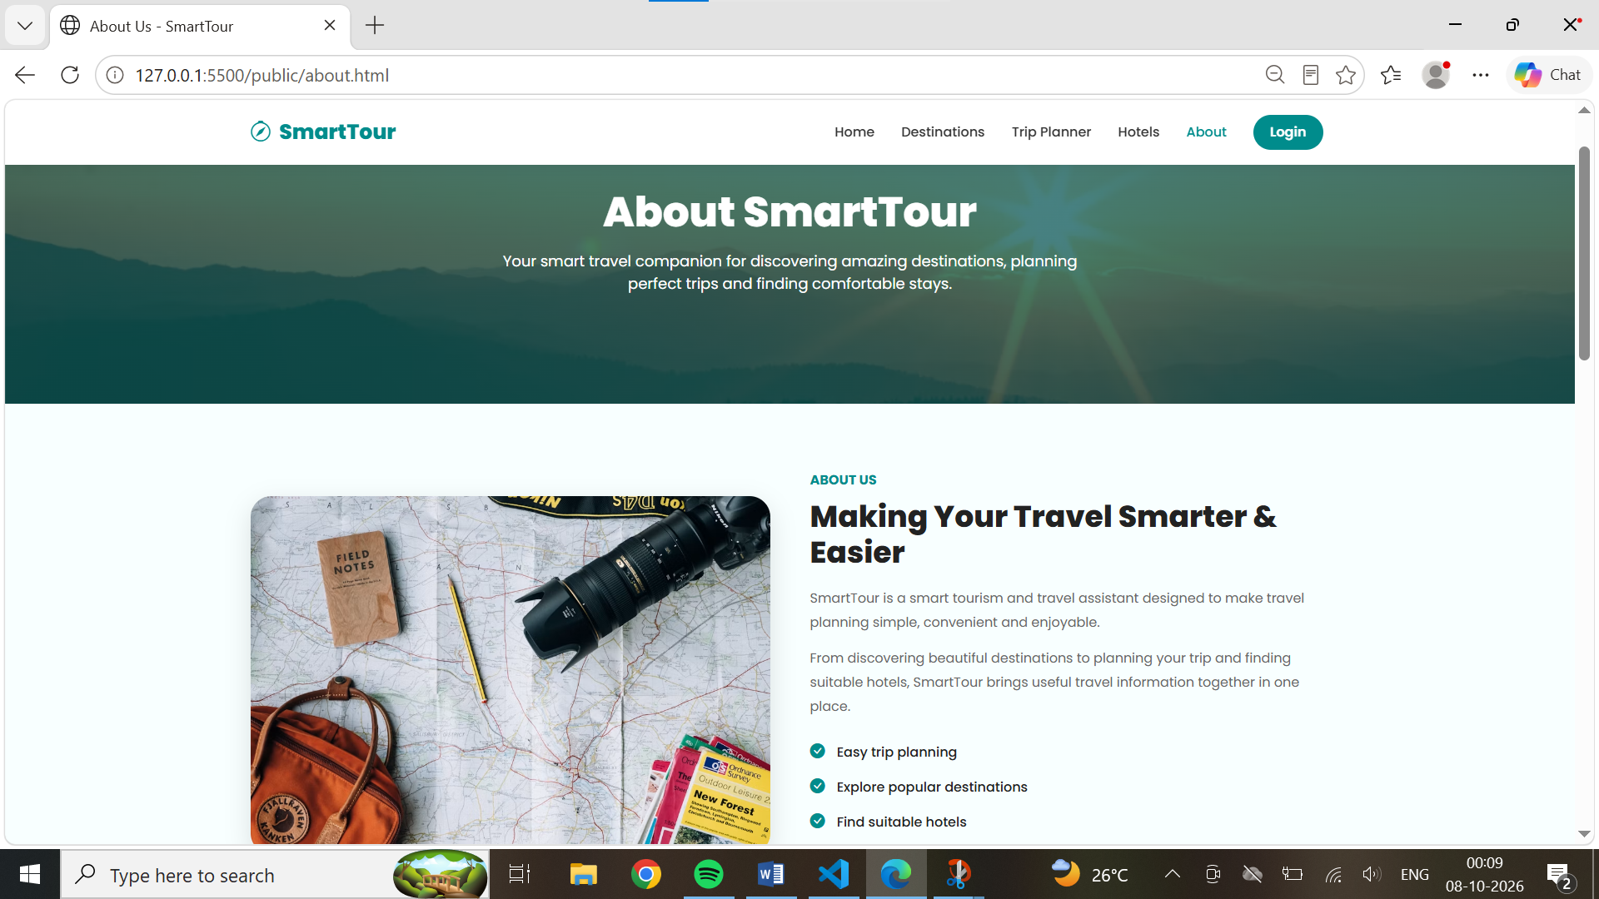

4.CODING

<!DOCTYPE html>
<html lang="en">

<head>
<meta charset="UTF-8">
<meta name="viewport" content="width=device-width, initial-scale=1.0">

<title>SmartTour - Smart Tourism & Travel Assistant</title>

<!-- Bootstrap CSS -->
<link href="https://cdn.jsdelivr.net/npm/bootstrap@5.3.3/dist/css/bootstrap.min.css" rel="stylesheet">

<!-- Bootstrap Icons -->
<link rel="stylesheet" href="https://cdn.jsdelivr.net/npm/bootstrap-icons@1.11.3/font/bootstrap-icons.min.css">

<!-- Google Font -->
<link href="https://fonts.googleapis.com/css2?family=Poppins:wght@400;500;600;700;800&display=swap"
rel="stylesheet">

<style>
* {
margin: 0;
padding: 0;
box-sizing: border-box;
}

body {
font-family: 'Poppins', sans-serif;
color: #222;
}

/* ================= NAVBAR ================= */

.navbar {
background: white;
box-shadow: 0 2px 15px rgba(0, 0, 0, 0.08);
padding: 14px 0;
}

.navbar-brand {
font-size: 25px;
font-weight: 800;
color: #0d8b8b !important;
}

.navbar-brand i {
margin-right: 6px;
}

.nav-link {
font-weight: 500;
color: #333 !important;
margin: 0 7px;
}

.login-btn {
border: 2px solid #0d8b8b;
color: #0d8b8b;
border-radius: 25px;
padding: 8px 20px;
font-weight: 600;
}

.login-btn:hover {
background: #0d8b8b;
color: white;
}

/* ================= HERO ================= */

.hero {
min-height: 650px;
background:
linear-gradient(rgba(0, 0, 0, 0.45), rgba(0, 0, 0, 0.45)),
url("https://images.unsplash.com/photo-1469474968028-56623f02e42e?auto=format&fit=crop&w=2000&q=85") center/cover no-repeat;

display: flex;
align-items: center;
color: white;
}

.hero-content {
max-width: 750px;
}

.hero-content h1 {
font-size: 55px;
font-weight: 800;
line-height: 1.2;
}

.hero-content h1 span {
color: #5ee6d6;
}

.hero-content p {
font-size: 18px;
margin-top: 20px;
line-height: 1.7;
}

.explore-btn {
background: #0d9b91;
color: white;
border: none;
padding: 13px 30px;
border-radius: 30px;
font-weight: 600;
margin-top: 15px;
text-decoration: none;
display: inline-block;
}

.explore-btn:hover {
background: #08766f;
color: white;
}

.plan-btn {
background: white;
color: #087c75;
border: none;
padding: 13px 30px;
border-radius: 30px;
font-weight: 600;
margin-top: 15px;
margin-left: 10px;
text-decoration: none;
display: inline-block;
}

.plan-btn:hover {

/* ================= FOOTER ================= */

footer {
background: #102c2c;
color: white;
padding: 55px 0 20px;
}

footer h5 {
font-weight: 700;
margin-bottom: 20px;
}

footer p {
color: #b8c7c7;
font-size: 14px;
line-height: 1.8;
}

footer ul {
padding: 0;
list-style: none;
}

footer ul li {
margin-bottom: 10px;
}

footer ul li a {
text-decoration: none;
color: #b8c7c7;
}

footer ul li a:hover {
color: white;
}

.social-icons a {
display: inline-flex;
width: 38px;
height: 38px;
border-radius: 50%;
background: #1d4545;
color: white;
align-items: center;
justify-content: center;
margin-right: 7px;
text-decoration: none;
}

.social-icons a:hover {
background: #0d9b91;
}

.copyright {
border-top: 1px solid #315050;
margin-top: 35px;
padding-top: 20px;
text-align: center;
color: #aababa;
font-size: 14px;
}

/* ================= RESPONSIVE ================= */

@media (max-width: 768px) {

.hero {
min-height: 600px;
text-align: center;
}

.hero-content h1 {
font-size: 38px;
}

.hero-content p {
font-size: 15px;
}

.search-box {
width: 100%;
}

.search-box input {
width: 65%;
}

.search-box button {
padding: 10px 15px;
}

.plan-btn {
margin-left: 0;
}

.section {
padding: 55px 0;
}

.section-title h2 {
font-size: 29px;
}

.why-img {
height: 300px;
margin-bottom: 30px;
}

.why-content h2 {
font-size: 29px;
}

.cta h2 {
font-size: 29px;
}
}

@media (max-width: 480px) {

.hero-content h1 {
font-size: 32px;
}

.explore-btn,
.plan-btn {
width: 100%;
margin-left: 0;
}

.search-box {
padding: 10px;
}

.search-box input {
width: 60%;
}

.search-box button {
padding: 9px 12px;
}
}
</style>
</head>

<body>

<!-- ================= NAVBAR ================= -->

<nav class="navbar navbar-expand-lg sticky-top">

<div class="container">

<a class="navbar-brand" href="index.html">
<i class="bi bi-compass"></i>
SmartTour
</a>

<button class="navbar-toggler" type="button" data-bs-toggle="collapse" data-bs-target="#navbarMenu">

<span class="navbar-toggler-icon"></span>

</button>

<div class="collapse navbar-collapse" id="navbarMenu">

<ul class="navbar-nav ms-auto align-items-lg-center">

<li class="nav-item">
<a class="nav-link" href="index.html">Home</a>
</li>

<li class="nav-item">
<a class="nav-link" href="destinations.html">
Destinations
</a>
</li>

<li class="nav-item">
<a class="nav-link" href="planner.html">
Trip Planner
</a>
</li>

<li class="nav-item">
<a class="nav-link" href="hotels.html">
Hotels
</a>
</li>

<li class="nav-item">
<a class="nav-link" href="about.html">
About
</a>
</li>

<li class="nav-item">
<a class="nav-link" href="help.html">Help</a>
</li>

<li class="nav-item ms-lg-2 mt-2 mt-lg-0">
<a class="login-btn" href="login.html">
Login
</a>
</li>

</ul>

</div>

</div>

</nav>

<!-- ================= HERO ================= -->

<section class="hero">

<div class="container">

<div class="hero-content">

<h1>
Explore The World,
<span>Travel Smarter.</span>
</h1>

<p>
Discover amazing destinations, plan your perfect trip,
find hotels and explore new experiences with
SmartTour – your smart travel assistant.
</p>

<a href="destinations.html" class="explore-btn">
<i class="bi bi-compass"></i>
Explore Destinations
</a>

<a href="planner.html" class="plan-btn">
<i class="bi bi-map"></i>
Plan My Trip
</a>

<!-- Search -->

<div class="search-box">

<i class="bi bi-search text-secondary"></i>

<input type="text" id="homeSearch" placeholder="Search destination...">

<button type="button" onclick="searchDestination()">
Search
</button>

</div>
</div>

</div>

</section>

<!-- ================= POPULAR DESTINATIONS ================= -->

<section class="section">

<div class="container">

<div class="section-title">

<h2>Popular Destinations</h2>

<p>
Explore some of the most beautiful places
for your next adventure.
</p>

</div>

<div class="row g-4">

<!-- Destination 1 -->

<div class="col-lg-4 col-md-6">

<div class="card destination-card">

<img src="https://images.unsplash.com/photo-1524492412937-b28074a5d7da?auto=format&fit=crop&w=900&q=80"
alt="Taj Mahal">

<div class="card-body">

<h5>Agra, India</h5>

<p>
Experience the beauty of the
iconic Taj Mahal and rich history.
</p>

<a href="destinations.html" class="view-btn">
Explore →
</a>

</div>

</div>

</div>

<!-- Destination 2 -->

<div class="col-lg-4 col-md-6">

<div class="card destination-card">

<img src="https://images.unsplash.com/photo-1564507592333-c60657eea523?auto=format&fit=crop&w=900&q=80"
alt="Jaipur">

<div class="card-body">

<h5>Jaipur, India</h5>

<p>
Discover royal palaces, forts
and colorful Rajasthani culture.
</p>

<a href="destinations.html" class="view-btn">
Explore →
</a>

</div>

</div>

</div>

<!-- Destination 3 -->

<div class="col-lg-4 col-md-6">

<div class="card destination-card">

<img src="https://images.unsplash.com/photo-1602216056096-3b40cc0c9944?auto=format&fit=crop&w=900&q=80"
alt="Kerala">

<div class="card-body">

<h5>Kerala, India</h5>

<p>
Enjoy peaceful backwaters,
beaches and beautiful nature.
</p>

<a href="destinations.html" class="view-btn">
Explore →
</a>

</div>

</div>

</div>

</div>

<div class="text-center mt-5">

<a href="destinations.html" class="explore-btn">
View All Destinations
</a>

</div>

</div>

</section>

<!-- ================= SERVICES ================= -->

<section class="section services-section">

<div class="container">

<div class="section-title">

<h2>Everything You Need For Your Journey</h2>

<p>
Smart tools to make your travel simple and enjoyable.
</p>

</div>

<div class="row g-4">

<!-- Service 1 -->

<div class="col-lg-3 col-md-6">

<div class="service-card">

<div class="service-icon">
<i class="bi bi-map"></i>
</div>

<h5>Trip Planner</h5>

<p>
Plan your trip easily according to
your destination and preferences.
</p>

</div>

</div>

<!-- Service 2 -->

<div class="col-lg-3 col-md-6">

<div class="service-card">

<div class="service-icon">
<i class="bi bi-building"></i>
</div>

<h5>Hotels</h5>

<p>
Find suitable hotels and
accommodation for your journey.
</p>

</div>

</div>

<!-- Service 3 -->

<div class="col-lg-3 col-md-6">

<div class="service-card">

<div class="service-icon">
<i class="bi bi-wallet2"></i>
</div>

<h5>Budget Planner</h5>

<p>
Estimate your travel expenses
and manage your trip budget.
</p>

</div>

</div>

<!-- Service 4 -->

<div class="col-lg-3 col-md-6">

<div class="service-card">

<div class="service-icon">
<i class="bi bi-cloud-sun"></i>
</div>

<h5>Weather</h5>

<p>
Check destination weather before
starting your journey.
</p>

</div>

</div>

</div>

</div>

</section>

<!-- ================= WHY CHOOSE US ================= -->

<section class="section why-section">

<div class="container">

<div class="row align-items-center g-5">

<div class="col-lg-6">

<img class="why-img"
src="https://images.unsplash.com/photo-1500534623283-312aade485b7?auto=format&fit=crop&w=1000&q=80"

<p>
<i class="bi bi-geo-alt"></i>
Maharashtra, India
</p>

</div>

</div>

<div class="copyright">

© 2026 SmartTour.
All Rights Reserved.

</div>

</div>

</footer>

<!-- Bootstrap JavaScript -->

<script src="https://cdn.jsdelivr.net/npm/bootstrap@5.3.3/dist/js/bootstrap.bundle.min.js"></script>

<script>
function searchDestination() {

let destination = document.getElementById("homeSearch").value.trim();

if (destination === "") {
alert("Please enter a destination.");
return;
}

window.location.href =
"destinations.html?search=" + encodeURIComponent(destination);
}
</script>
</body>

</html>

5. TESTING

5.1 TEST STRATEGY
The test strategy for the SAFEHAVEN: Women Safety Emergency Response System defines the overall approach used to verify that the system works correctly, reliably, and securely. Since SAFEHAVEN handles emergency alerts, user information, emergency contacts, and location data, testing is important to ensure that all major functions perform as expected.
The testing process focuses on identifying errors, verifying individual features, checking communication between different modules, and confirming that the complete system meets its specified requirements.

5.1.1 OBJECTIVES OF TESTING
The main objective of testing the SAFEHAVEN: Women Safety Emergency Response System is to ensure that the system functions correctly, reliably, securely, and according to the specified requirements. Testing helps identify errors and verifies that all important features work as expected.
The major objectives of testing are:
- Verify Functionality: To ensure that all system features work according to the defined requirements.
- Test User Registration: To verify that users can successfully register by entering valid information.
- Test Login: To ensure that registered users can log in using valid credentials and unauthorized users are prevented from accessing the system.
- Test Emergency Contacts: To verify that users can add, update, view, and delete emergency contacts correctly.
- Test SOS Function: To ensure that the SOS button generates an emergency alert correctly when activated.
- Test Location Services: To verify that the system can obtain the user's current location through GPS or geolocation services.
- Test Emergency Notifications: To ensure that emergency information is delivered to the selected emergency contacts through the implemented communication method.
- Test Database: To verify that user details, contacts, SOS alerts, and location information are stored and retrieved correctly.
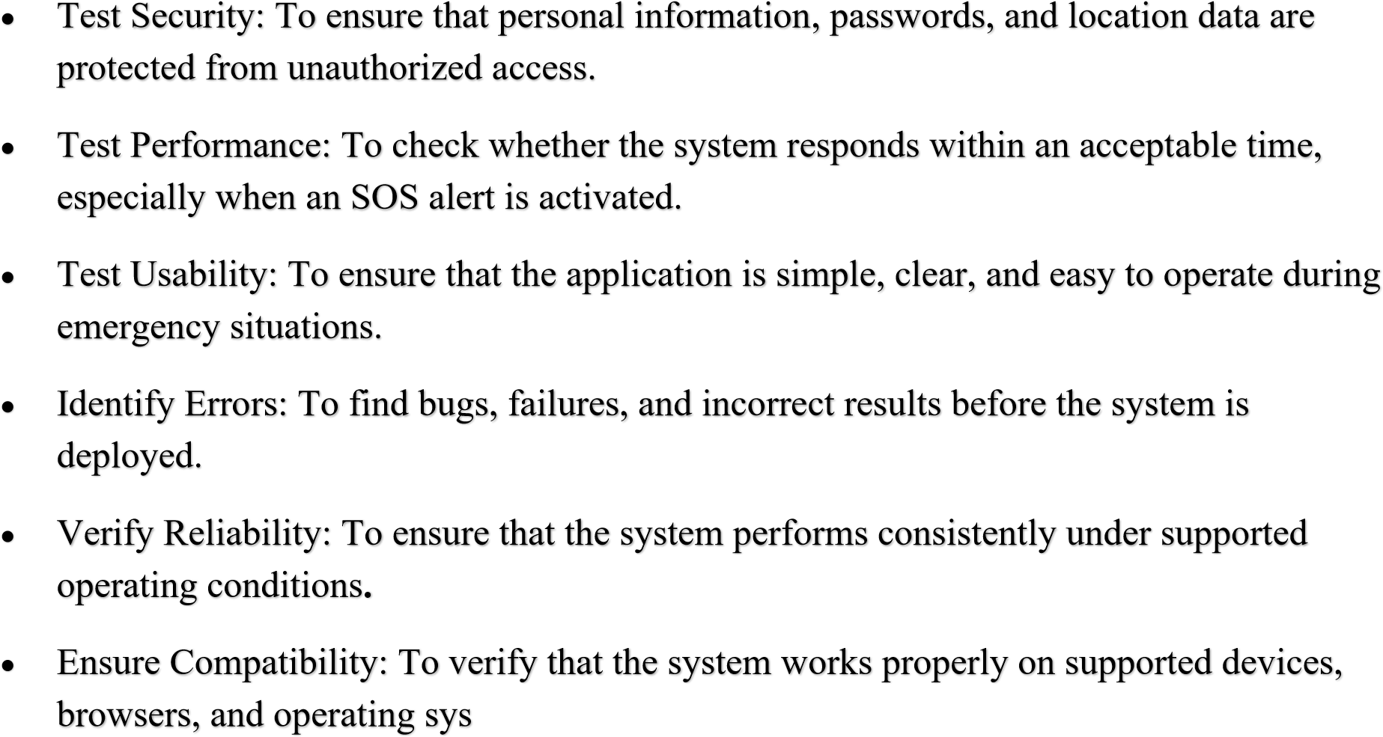
5.1.2 Types of Testing

1. Unit Testing
Unit Testing is the process of testing individual modules or components of the SAFEHAVEN: Women Safety Emergency Response System separately. The main purpose of unit testing is to verify that each module performs its intended function correctly before it is integrated with other modules.
Integration testing checks whether different modules work correctly together. For example, when the user activates SOS, the system should correctly connect the SOS module with the location service, database, and emergency notification

3.Integration Testing
Integration Testing is the process of testing two or more modules together to verify that they communicate and work correctly. In the SAFEHAVEN: Women Safety Emergency Response System, integration testing ensures that data is transferred correctly between different modules and that the complete workflow operates as expected.

4.Functional Testing
Functional Testing is the process of verifying whether the SAFEHAVEN: Women Safety Emergency Response System performs all its specified functions correctly. It focuses on testing the expected behavior of the system based on the project requirements.

5.Performance Testing
Performance Testing is the process of evaluating the speed, responsiveness, stability, and resource usage of the SAFEHAVEN: Women Safety Emergency Response System. The main purpose is to ensure that the system responds efficiently to user actions and remains stable under expected operating conditions.

4.Security Testing
Security Testing is the process of checking whether the SAFEHAVEN: Women Safety Emergency Response System protects user information and prevents unauthorized access to the system. Since SAFEHAVEN handles sensitive information such as personal details, passwords, emergency contacts, SOS alerts, and location data, security testing is an important part of the project.

5.Usability Testing
Usability Testing is the process of evaluating how easily users can understand and operate the SAFEHAVEN: Women Safety Emergency Response System. The main purpose is to ensure that the system has a simple, clear, and user-friendly interface

6.Compatibility Testing
Compatibility Testing is the process of checking whether the SAFEHAVEN: Women Safety Emergency Response System works correctly across different devices, operating systems, web browsers, screen sizes, and network environments.

5.1.3 Testing Approach
The Testing Approach defines the systematic process used to verify and validate the
SAFEHAVEN: Women Safety Emergency Response System. The main purpose of testing is to ensure that the system meets its requirements, performs correctly, and provides reliable results under supported conditions.

5.1.3 TESTING APPROACH
The Testing Approach defines the systematic method used to test the SAFEHAVEN: Women Safety Emergency Response System. The main purpose of the testing approach is to verify that all system functions work correctly, identify errors, and ensure that the system satisfies the specified requirements.

5.1.3 TESTING APPROACH
The Testing Approach for the SAFEHAVEN: Women Safety Emergency Response System describes the methods and steps followed to test the system. The purpose of testing is to ensure that the system meets its requirements and that all important functions work correctly.







- The Registration Page is tested to ensure users can register with valid details and proper validation messages are shown for invalid inputs.
- The Login Page is tested to verify correct authentication and error handling.
- The Menu Page is tested to check whether food items are displayed correctly.
- The Cart Page is tested to ensure items are added, removed, and updated properly.
- The Order/Payment Page is tested to verify that orders are placed successfully and data is stored correctly.
- The Home Page is tested for proper navigation and functionality.

5.3 INTEGRATION TESTING PLAN


Integration testing is performed to verify the interaction between different modules of the
system.

In this system, integration testing ensures that:

•

The data entered during registration is correctly used during login.

•

After successful login, the user is redirected to the Home Page.

•

Food items selected from the Menu Page are correctly added to the Cart Page.

•

The cart data is properly passed to the Order/Payment Page.

•

The order details are correctly stored in the database and displayed to the user.

5.4 SYSTEM TESTING PLAN

System testing is performed to evaluate the complete system as a whole and ensure that it meets
the specified requirements.

In the Online Food Ordering System, system testing includes:

•

Verifying all functionalities from registration to order placement.

•

Checking system performance under different conditions.

•

Ensuring data consistency between frontend and backend.

•

Validating user interface and user experience.

•

Testing system behaviour with valid and invalid inputs.

•

The system is considered successful if all features work correctly, performance is stable, and the
application meets user requirements without any major defects.

6. ADVANTAGES AND DISADVANTAGES

Advantages
- Quick SOS Alert: Users can activate an emergency alert quickly during an unsafe situation.
- Location Sharing: The system can obtain and share the user's available location with configured emergency contacts.
- Easy to Use: A simple and user-friendly interface makes important safety features easier to access.
- Emergency Contact Management: Users can add, update, and manage trusted contacts in the system.

Disadvantages
Although SAFEHAVEN: Women Safety Emergency Response System provides useful emergency-support features, it has some limitations and disadvantages:
- Internet Dependency: Features that require online communication may not work properly without an internet connection.
- GPS Dependency: Location sharing depends on the availability and accuracy of GPS or device location services.

7.PURPOSE ENHANCEMENT
The main purpose of the SAFEHAVEN: Women Safety Emergency Response System is to provide a simple and technology-based platform for assisting women during emergency situations. The system is designed to reduce the effort required to communicate an emergency and provide important information to trusted contacts.
Computes route safety indices using real-time inputs: operational streetlights, open commercial storefronts, historical police patrol logs, and CCTV density.
Flags unexpected stops, unscheduled route changes, or prolonged stationary intervals during transit via background telemetry.
Requires micro-confirmations during high-risk trips (e.g., tap or biometric match every 10 minutes); triggers tier-1 escalation automatically if missed.
Direct computer-aided dispatch (CAD) packet injection bypasses phone queues, transferring real-time coordinates, victim profile, and priority telemetry instantly.
Pings vetted, background-checked community volunteers and commercial guards within a 200– 400 meter radius for immediate deterrence before police arrive.
Employs binary-compressed SMS and P2P mesh networking (BLE/Wi-Fi Direct) when cellular data infrastructure fails or is jammed.
Encrypts and SHA-256 hashes auto-recorded ambient audio, front/rear camera bursts, and GPS breadcrumbs at capture time, ensuring chain-of-custody compliance.
Supports a silent duress PIN that visually mimics an app shutdown or alert cancellation while secretly maintaining continuous live telemetry to dispatchers.
Instantly offloads encrypted buffer slices to remote read-only storage so evidence survives device destruction or forced reset.

8. Conclusion
The SAFEHAVEN: Women Safety Emergency Response System is a technology-based solution developed to support women during emergency and unsafe situations. The system brings important safety features such as user registration, emergency contact management, SOS alerts, location sharing, emergency notifications, and alert history into a single platform.
The main objective of the project is to provide a simple and quick method for a user to communicate an emergency situation to trusted contacts. The SOS feature allows the user to initiate an emergency alert, while location services can provide the user's available geographical location. A Women Safety Emergency Response System bridges the critical gap between a moment of distress and real-world intervention. Technology alone—whether a discreet wearable, an automated transit monitor, or a background mobile app—only fulfills its purpose when backed by a resilient, low-latency infrastructure capable of routing accurate situational data under adverse conditions.
The true efficacy of such a platform relies on three pillars:
Failsafe Redundancy: Ensuring triggers and telemetry reach responders even in lowconnectivity environments through cellular fallback and offline-first protocols.
Operational Integration: Direct, friction-free coordination between private networks (family, trusted contacts) and public safety infrastructure (police dispatch, emergency services).
Privacy & User Agency: Balancing continuous protection with strict data governance, tamperresistant evidence logging, and intuitive controls that minimize false alarms without compromising emergency readiness

9.BIBLIOGRAPHY
- Pressman, R. S. and Maxim, B. R., Software Engineering: A Practitioner's Approach, McGraw-Hill Education.
- Sommerville, I., Software Engineering, Pearson Education.
- Elmasri, R. and Navathe, S. B., Fundamentals of Database Systems, Pearson.
- Mozilla Developer Network (MDN), JavaScript Documentation, Mozilla.
- Node.js, Node.js Documentation, OpenJS Foundation.
- Firebase, Firebase Documentation, Google.
- MongoDB, MongoDB Documentation, MongoDB Inc.
- W3Schools, HTML, CSS and JavaScript Tutorials, W3Schools.
- Android Developers, Android Developer Documentation, Google.
- World Wide Web Consortium (W3C), Geolocation API Specification, W3C.
- International Software Testing Qualifications Board (ISTQB), Foundation Level Software Testing Syllabus.
- Open Worldwide Application Security Project (OWASP), Web Security Testing Guide.
- Google Developers, Geolocation and Location Services Documentation.
- TutorialsPoint, Software Engineering and Web Development Tutorials.
- GeeksforGeeks, Web Development, JavaScript, Database and Software Engineering Resources.

